

MS-SAR1000
Slope Monitoring Radar User Manual
©2024, ComNav Technology Ltd. All rights reserved. SinoGNSS® is the trademark of ComNav Technology Ltd., registered in People’s Republic of China, United States of America and European Union. All other trademarks are the property of their respective owners.

Border Approval Form
revise | signature | date
Submitter
Collator
Approver

Document number | current version | release date

Edit History
revised version | revise content | revise content
1.0 | Newly Release | 2024.8.1

Introduction

Purpose
This manual provides a module-by-module detailed introduction to the purpose, functions, and operational procedures of the MS-SAR1000 Universal Slope Monitoring Radar. The language style is concise and easy to understand, with operation procedures described clearly and simply, enabling beginners to learn how to use each operational step easily, quickly, and accurately.

Technical Service
Upon purchasing any Sinognss product, users will enjoy long-term technical services and upgrade policies provided by ComNav Technology Ltd.
Our company website is: http://www.sinognss.com. Users can stay informed about the latest developments in Sinognss software and hardware, and download the latest versions of relevant products and technical documentation from the website.

Your Suggestions
If you have any suggestions or comments regarding our software or manuals, please leave a message via the "Online Consultation" section on the Sinognss official website, send an email, or call us. Your feedback will greatly contribute to improving the quality of our products.

Disclaimer
Sinognss is committed to continuously improving product functions and performance. Product specifications and manual contents may be subject to change without prior notice. If there are any discrepancies between the icons/pictures in the manual and the actual product, the physical product shall prevail.
Please be sure to read this manual carefully before using this product. Sinognss shall not be held liable for any losses caused by failure to follow the instructions in the user manual or by misoperation resulting from incorrect understanding of the manual's instructions.

Product Introduction

Overview
The Sinognss MS-SAR1000 Universal Slope Monitoring Radar is based on Synthetic Aperture Radar imaging technology and interferometric/differential interferometric techniques. It is specifically designed for monitoring and early warning of geological hazard types such as landslides, collapses, and subsidence at potential geological disaster sites. The radar features a low-cost, low-power, and universal design, offering advantages including full 360° coverage, sub-millimeter deformation measurement, and all-weather, day-and-night non-contact remote sensing scanning. Additionally, specifically tailored to the "long-term online, unattended" requirements of geological hazard sites, the design emphasizes unmanned operation, ultra-low power consumption, multi-radar connectivity, multiple power supply options, and multi-platform integration. It also integrates a variable-focus visual sensor for periodic inspection, key location observation, and auxiliary assessment. The system enables planar, multi-point, long-distance, and long-term monitoring and scanning of observed scenes (geological hazard sites, hydraulic engineering projects, railways, highways, and other geological bodies and major infrastructure) to extract deformation data, achieving long-term unmanned monitoring and automated early warning.

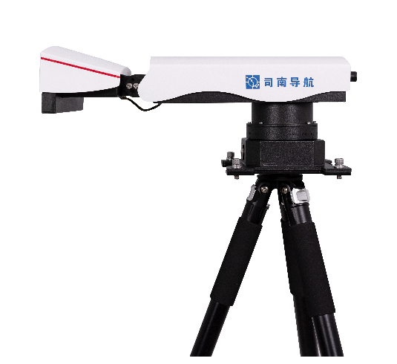

Main Technical Specifications
Type | Technical Parameter
Operating Frequency Band | Ku-band
Maximum Range | ≥800m
Coverage Angle | ≥360° (horizontal, or specified sector) × 40° (elevation)
Deformation Accuracy | ≤0.5 mm (at any angle within 360° azimuth)
Range Resolution | ≤0.3m
Azimuth Resolution | ≤9mrad
Data Acquisition Cycle | ≤1min
Elevation Adjustment Angle | ≥±45°
Data Upload Interval | Configurable from 1 min to 24 h
Communication Method | Built-in 4G/5G; equipped with mobile communication/WAN/satellite communication interfaces; supports local inter-device networking linkage
Communication Standard | Compliant with GB/28181 and DZ/T 0450-2023; encrypted data transmission
Total Power Consumption | ≤15W
Total Weight | ≤5kg
Maximum Radar Main Unit Dimensions | ≤0.6m
Operating Temperature | -40~65℃
Maximum Altitude | ≥6000m
Protection Rating | IP65
Wind Resistance Rating | ≥Level 12
Edge Computing | The main unit uses edge front-end computing, completing all processing internally without the need for external processing equipment
Power Supply | Supports multiple power supply methods including mains/solar/battery; equipped with overvoltage and undervoltage protection

Product Features
- Universal for Geological Hazards: Specially customized to meet the universal requirements of domestic geological hazard site scenarios.
- Arc Imaging and Continuous Wave Radar System: Enables 360° or specified sector monitoring with no blind spots in angle or distance.
- No Protective Shelter Required: Withstands outdoor wind, sun, rain, dust, and heavy snow; no monitoring shed needed; IP65 protection; normal operating temperature of -40°C to 65°C; Level 12 wind resistance.
- Lightweight and Compact Design: Weight ≤5 kg, total length ≤0.6 m, portable by a single person or carried on the back to the installation site.
- High Reliability: 24/7 uninterrupted reliable scanning, service life >5 years.
- 3D Terrain Fusion Registration Accuracy: Better than 1 meter.
- All-Weather, Day-and-Night, Planar Monitoring (including multi-point monitoring mode): Strong penetration, unaffected by rain, snow, fog, smoke, dust, strong light, or night conditions.
- Innovative Adaptive Monitoring and Early Warning: Automatic assessment, automatic early warning, unattended operation.
- Built-in Wireless Router: Quick setup and configuration, multi-radar cloud connectivity, centralized management.
- B/S Architecture Software: Supports simultaneous access by multiple users.
- Manually Adjustable Antenna Elevation Orientation: Adaptable to flexible monitoring in high-relief mountain valley terrain.

Hardware Installation Guide

Radar Installation Site Selection
(1) Installation Location
Ensure that the ground at the radar installation site is free from subsidence, collapse, landslide, or other phenomena. There should be no interfering obstacles or buildings within a 5-meter diameter, ensuring the radar operates safely without interference.
(2) Installation Levelness
Ensure that the ground where the radar is installed is level, with no settlement occurring after rain or snow, to keep the radar horizontally mounted. Ground leveling construction may be carried out prior to installation. If conditions permit, a concrete floor may be laid.
(3) Installation Environment
The radar installation site must be free from strong magnetic or electrical interference.
There should be no tall buildings obstructing the surrounding area, as this may affect the normal operation of the radar's built-in satellite compass.

Radar Installation Steps

Unpacking the Radar
Open the radar packaging box, grasp the radar by its handles with both hands, and slowly lift it out of the packaging box.
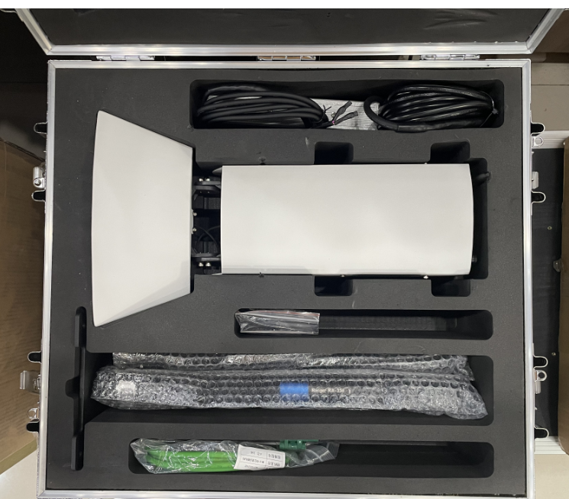

Securing the Radar to the Tripod
Extend the tripod legs and spread them evenly. After removing the radar, align the radar base with the top center hole of the tripod according to the arrow direction indicated on the flange of the central mounting base. Hand-tighten the four locking screws securely.
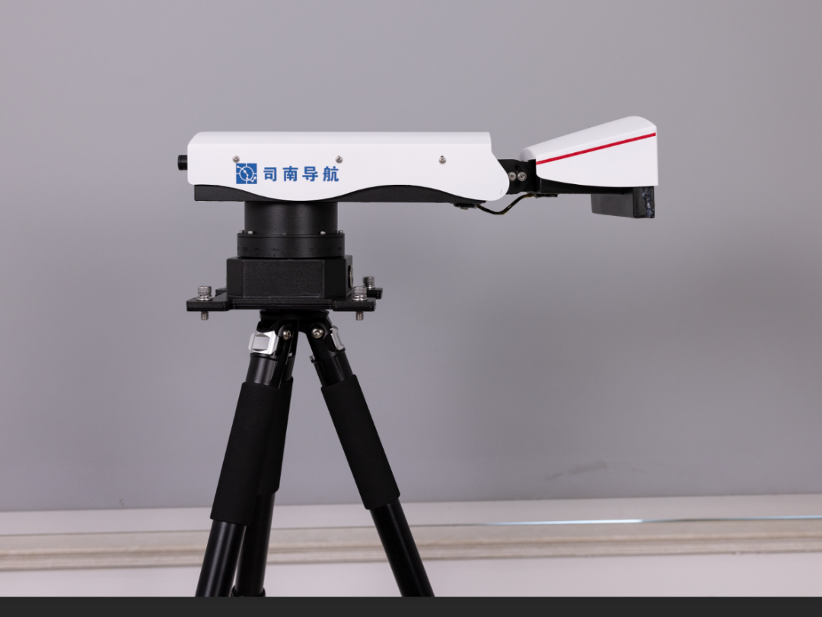

Connecting the Radar Power and Network Cables
The power and network cables are pre-assembled at the factory and can be used directly. Connect them following the corresponding alignment of the aviation plugs and interfaces.

Radar Integrity Check (Initial Unpacking)
After the radar installation and setup is complete, inspect the overall structure of the radar to confirm that all component units are structurally intact, free from deformation or other abnormalities. If any anomaly is found, contact support for assistance.

Cable Requirements
Always use the original supporting cables provided by our factory. It is strictly prohibited to arbitrarily cut or reconnect the cables. (All cables used by the radar are pre-assembled before delivery.)

Radar Power On/Off Operation

Radar Power-On Operation
(1) Power-On Confirmation
Connect the radar power and network cables and verify the connections.
(2) Power Switch Operation
After confirming power, press the power button on the base. When the indicator light illuminates, it indicates the radar is powered on.
(3) Confirming Successful Radar Power-On
After power-on, if the radar's motion position is not at the origin, it will perform a homing movement, and the antenna end will initialize. This indicates that the radar has powered on successfully.

Radar Power-Off Operation
(1) Confirmation Before Shutdown
Before shutting down, use the software to control the radar to "Stop Operation" and confirm that the radar's rotational movement position has returned to the origin.
(2) Shutdown Operation
Press the radar power switch button. When the button's indicator light goes out, it indicates successful shutdown.
Note:
- Confirming that the radar has returned to the origin before shutdown saves time during the next power-on homing process.
- Confirming that the radar has returned to the origin before shutdown ensures that the radar base position aligns with the inner lining position of the packaging box, making it easier to place the radar back into the packaging box.

Software User Guide

Software Registration
Open the website (https://www.comnavtech.com/) , click the Register Now button on the login page, and fill in the registration information.

System Login
Open the login address, enter the registered account, password, and verification code, then you can log in successfully (as shown in Figure 3-1). If an invalid account is entered, the login will fail, and you can contact the administrator for assistance based on the error message (as shown in Figure 3-2).
[Username] — [Password] — <Login> — Enter the platform
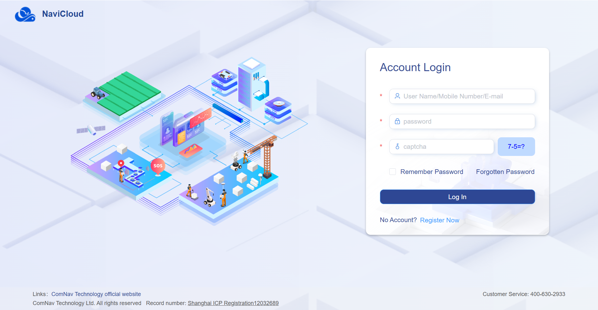
Figure 3-1 Login Page

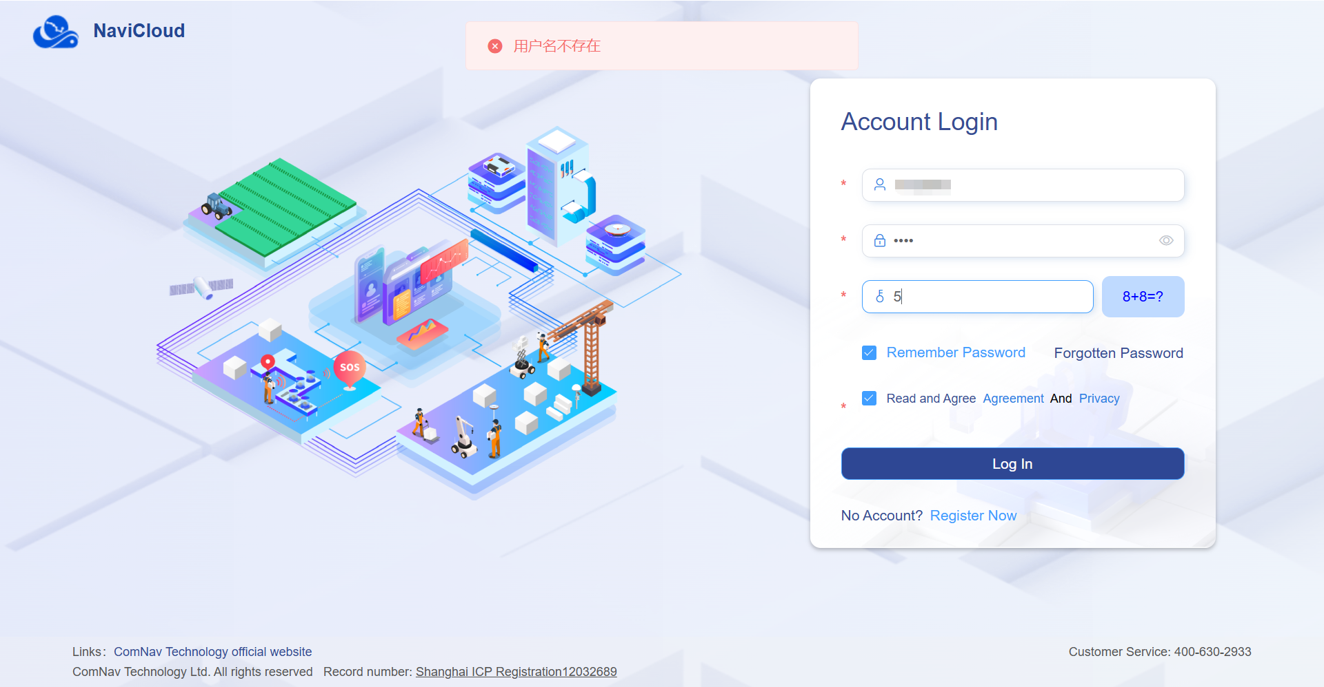
Figure 3-2 Invalid Login

Data Overview

Map Display
In the "Data Overview" module, the map service is running normally, and the projects associated with the current account are distributed at their corresponding actual locations (as shown in Figure 3-3). You can adjust the map scale by scrolling the mouse wheel to zoom in and out. Click the check box in the lower-left corner to select different maps (as shown in Figure 3-4).
[Satellite Map (Layer Selection Box)] — Switch Map
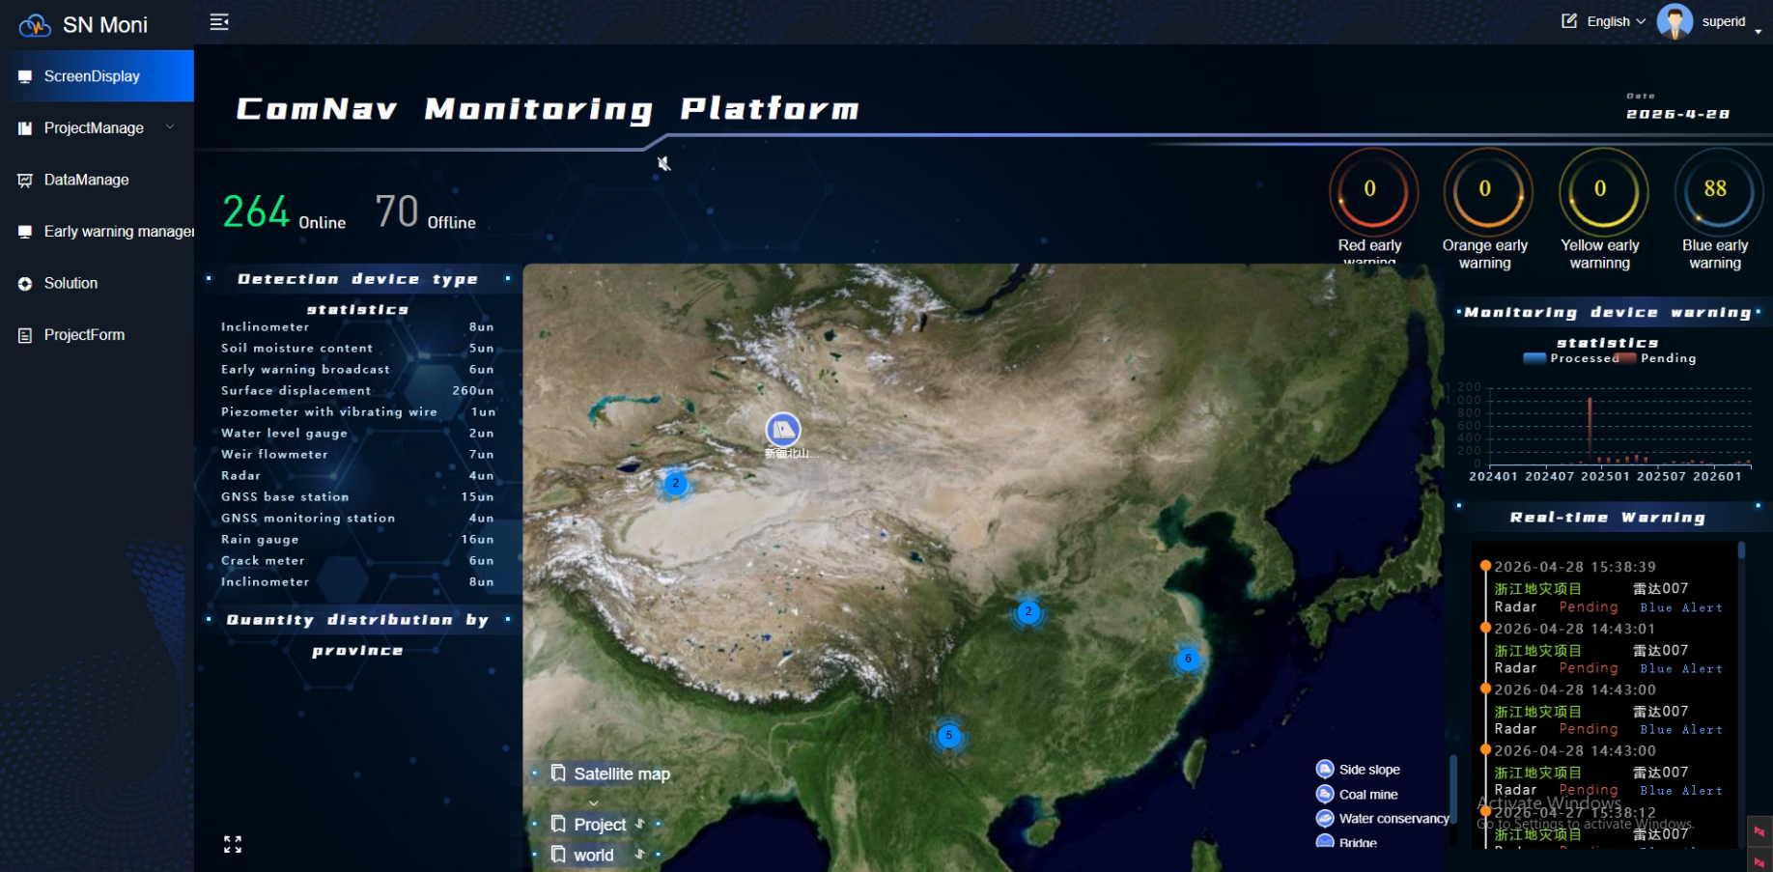
Figure 3-3 Data Overview Page

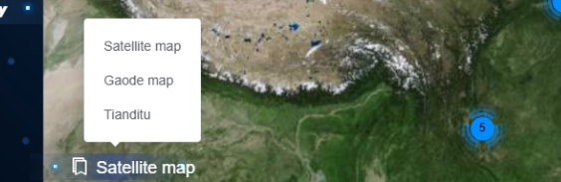
Figure 3-4 Map Switching

Data Display
In the upper-left corner of the "Data Overview" module, the total number of offline and online devices bound to the current account, as well as the total data volume, are displayed.
On the left side of the "Data Overview" module, statistics on various types of sensors bound to the current account are displayed.
In the lower-left corner of the "Data Overview" module, the provincial distribution of devices bound to the current account is shown.
In the upper-right corner of the "Data Overview" module, the date and local weather conditions are displayed.
On the right side of the "Data Overview" module, the early warning distribution and early warning processing status are displayed.
In the lower-right corner of the "Data Overview" module, pop-up alarms are supported. When a site's monitoring value exceeds the threshold, the correct alarm information will be displayed (as shown in Figure 3-6).
Figure 3-5 Project Search
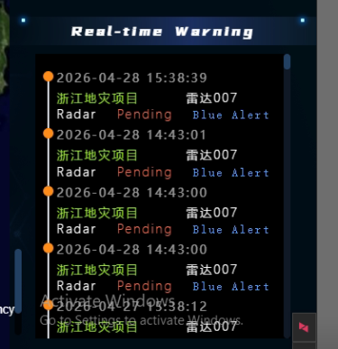

Figure 3-6 Pop-up Alarm

Project Map Display
Click on the project name on the map in the "Data Overview" module to jump to the project map for that project, displaying the various sites under the current project (as shown in Figure 3-7)
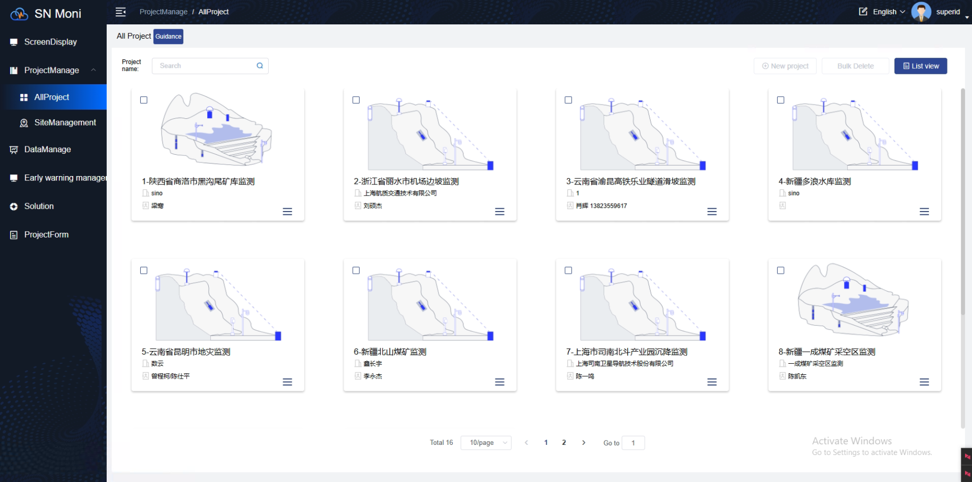

Figure 3-7 Project Information Display

Universal Radar Monitoring Dashboard

Dashboard Display
The upper-left corner of the monitoring dashboard contains a "Return to Data Overview" link.
The upper-right corner of the monitoring dashboard displays the time and weather information for the radar's location.
The middle of the monitoring dashboard shows the project name.
On either side of the project name are toolbars. The left toolbar, from left to right, includes Map View Lock (once locked, the dashboard will default to this view each time it is entered), Early Warning Statistics, Add Monitoring Point, and Add Monitoring Surface. The right toolbar, from left to right, includes Map Selection, Full Screen (support exiting with ESC key), and Settings.
The left window of the monitoring dashboard includes information management display for radar devices, radar images, and radar monitoring points. The window supports collapsing and expanding (expanded by default).
The right window of the monitoring dashboard displays early warning statistics by default. The window supports collapsing and expanding (expanded by default).
The central main area of the monitoring dashboard displays information such as maps, radar images, and radar monitoring point icons.
The "Graded Display" switch, when turned on, changes the color rendering effect of the radar deformation map to a graded mode. (As shown in Figure 3-8)
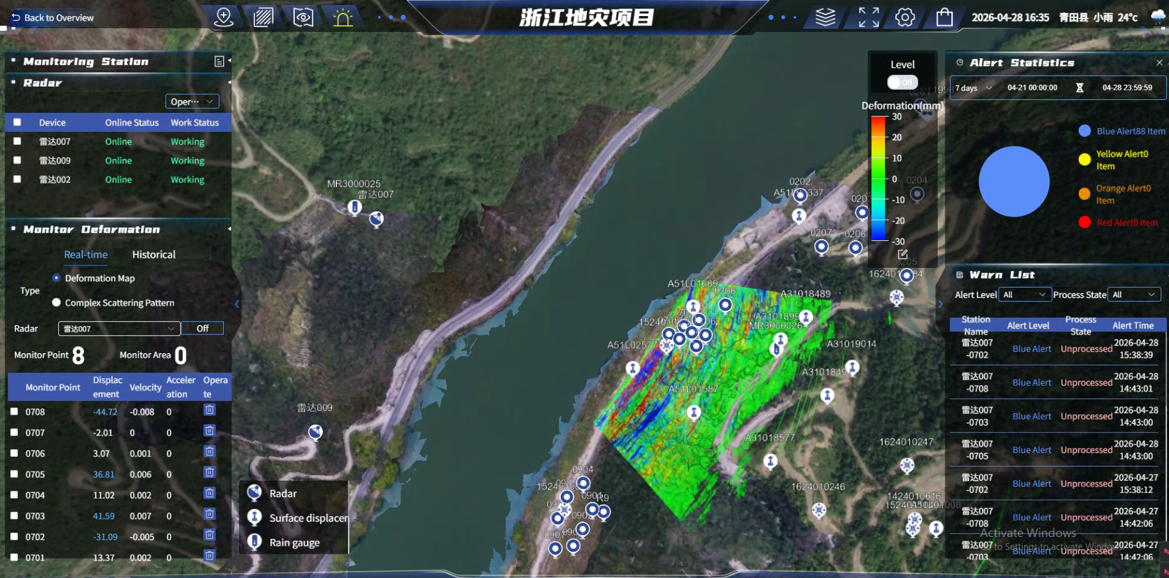
Figure 3-8 Dashboard Display

Radar Device
The radar device list displays the radar device name, online status, and working status.
After selecting a radar device in the list, you can choose from "Start Operation," "Stop Operation," and "Restart" (function not yet enabled) in the "Actions" menu to control the radar device. (As shown in Figure 3-9)
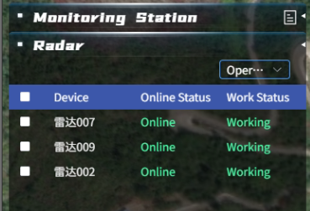
Figure 3-9 Radar Device List

Radar scanning parameter settings are supported on the dashboard.
Open the settings window through the toolbar: <Settings> — <System Settings> — Radar Scan Parameters
Each time the scan parameters are set and saved successfully, a new radar monitoring task will be generated. The previous radar monitoring data will be saved as a historical task and can be viewed in the Historical Deformation Monitoring section. (As shown in Figure 3-10)
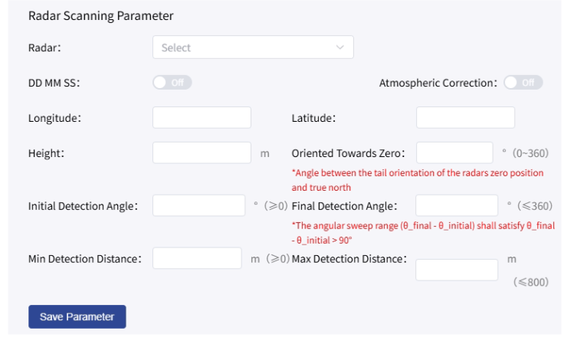
Figure 3-10 Radar Scan Parameter Settings

Radar Image
Supports viewing and displaying both real-time and historical radar images.
For real-time images, both deformation maps and multi-scatter maps can be viewed. After selecting a radar, the real-time image of that radar is displayed on the map. The image will be automatically updated on the screen each time new image data is received by the backend.
After clicking the "Close Image" button, the radar image will no longer be displayed on the map, and the button will change to "Open Image." Click "Open Image" to restore the image display. (As shown in Figure 3-11)
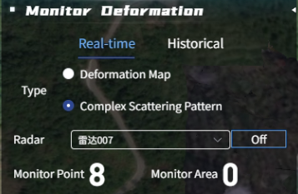
Figure 3-11 Radar Real-Time Image

For historical images, both deformation maps and multi-scatter maps can be viewed. After selecting a radar, you need to first select the historical period to view, then select the specific time range (Note: the time range must fall within the selected historical period). After selecting the time, click the "Query" button to display the historical image on the map. (As shown in Figure 3-12)
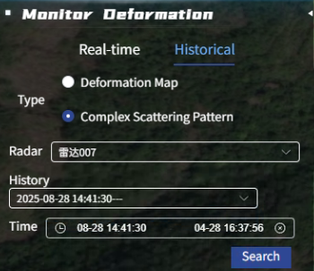
Figure 3-12 Radar Historical Image

Radar image function settings are supported on the dashboard.
Open the settings window through the toolbar: <Settings> — <System Settings> — Image Rendering
After selecting a radar, you can choose to disable or enable the scatter image and deformation image functions for that radar.
In the Image Frame Extraction setting, you can set how many rotations of the radar generate one image. (As shown in Figure 3-13)
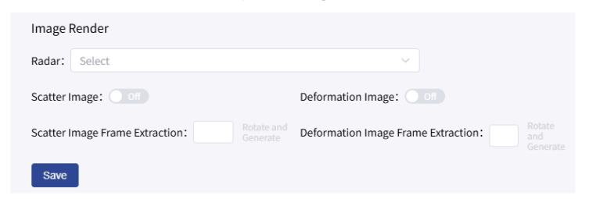
Figure 3-13 Radar Image Settings

Radar Monitoring Points
(1) Add Monitoring Points
Click the "Add Monitoring Point" icon in the toolbar to open the monitoring point addition window. You need to select the radar to which the monitoring point will be bound (the added monitoring point must be within the radar scanning range), choose the addition method as "Map Point Selection," enter the monitoring point name, and then click "Next" to enter the dashboard and double-click a point on the map. After the monitoring point information pops up, confirm to complete the addition. (As shown in Figure 3-14)
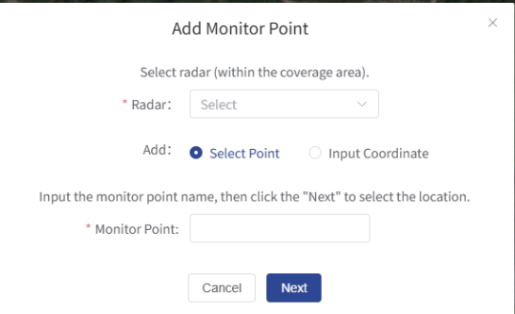
Figure 3-14 Add Monitoring Point
If you select "Manual Coordinate Entry" as the addition method, you can skip the map point selection step, directly enter the coordinate information, click "Next," and confirm the information to complete the addition. (As shown in Figure 3-15)
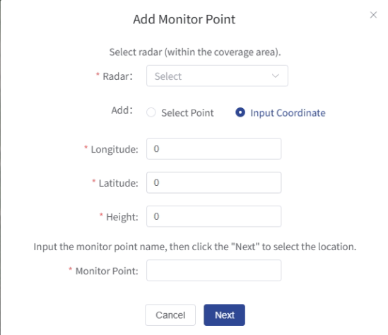
Figure 3-15 Add Monitoring Point – Manual Coordinate Entry
(2) Monitoring Point List
Under real-time deformation, the monitoring point list displays device name, monitoring point name, deformation displacement, deformation velocity, and deformation acceleration information. The list supports the deletion operation for monitoring points, and a count of monitoring points is displayed at the top of the list. (As shown in Figure 3-16)
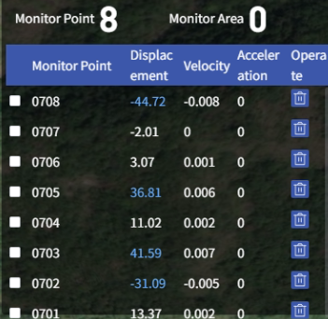
Figure 3-16 Real-Time Monitoring Point List

Under historical deformation, the monitoring point list displays device name, monitoring point name, monitoring point longitude, monitoring point latitude, and monitoring point elevation information. A count of monitoring points is displayed at the top of the list. (As shown in Figure 3-17)
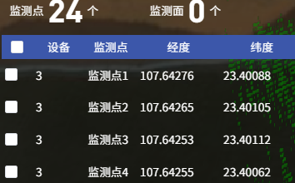
Figure 3-17 Historical Monitoring Point List
(3) Monitoring Point Information
Click on a monitoring point icon on the map to pop up detailed monitoring point information in the upper-right corner of the screen. (As shown in Figure 3-18)
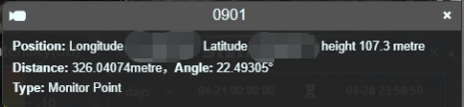
Figure 3-18 Monitoring Point Information

(4) Deformation Curve
After selecting monitoring points in the monitoring point list, a deformation curve window will pop up on the right side of the dashboard, displaying the deformation displacement curve, deformation velocity curve, and deformation acceleration curve for that monitoring point. (As shown in Figure 3-19)
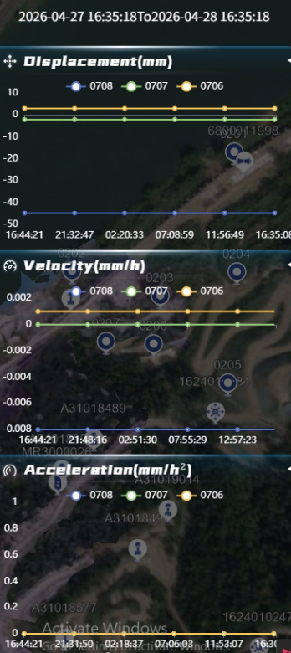
Figure 3-19 Deformation Curve

(5) Monitoring Point Threshold
Threshold modification for monitoring points is supported on the dashboard.
Open the settings window through the toolbar: <Settings> — < Point Threshold>
(Note: The radar device needs to have a threshold template bound in the backend first; the default threshold for monitoring points is the threshold in the threshold template.)
In the Monitoring Point Threshold window, after selecting a radar, you can view the threshold list for the monitoring points under that radar. Click "Modify" to change the threshold for a single monitoring point. (As shown in Figure 3-20)
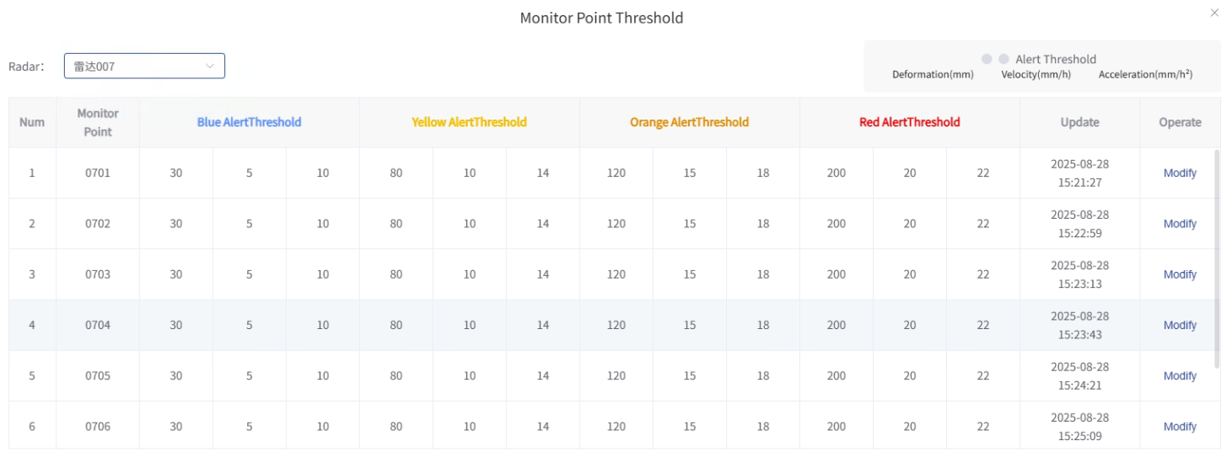
Figure 3-20 Monitoring Point Threshold

Early Warning Statistics
The right window of the dashboard displays early warning statistics by default. The early warning statistics window can be closed or opened via the early warning statistics icon on the toolbar. The early warning statistics window consists of two parts: early warning statistics and early warning list.
The time range for statistics can be freely switched or entered. (As shown in Figure 3-21)
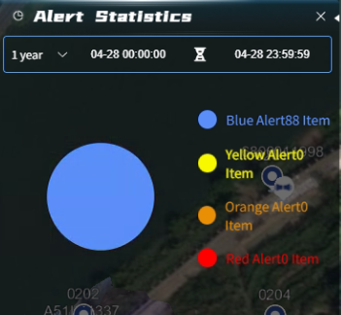
Figure 3-21 Early Warning Statistics
The early warning list displays all early warning records, which can be filtered and viewed by early warning level (Blue Warning, Yellow Warning, Orange Warning, Red Warning) and processing status (Unprocessed, Processed). (As shown in Figure 3-22)
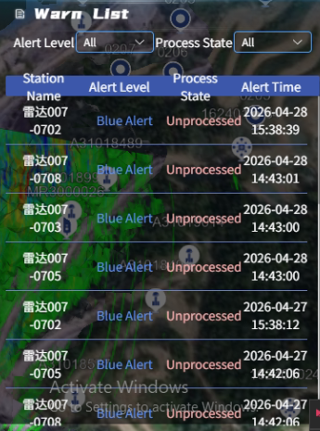
Figure 3-22 Early Warning List

Map Selection
The map selection window can be opened and closed via the Map Selection icon on the toolbar.
The map selection window consists of two parts: Select Map and Select Layer.
Select Map allows you to choose the base map to be displayed on the dashboard. (As shown in Figure 3-23)
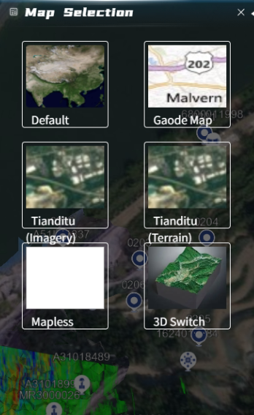
Figure 3-23 Select Map
Select Layer allows you to load terrain or 3D models onto the base map (terrain and 3D model files need to be uploaded in advance). (As shown in Figure 3-24)
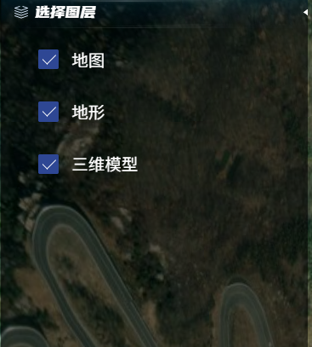
Figure 3-24 Select Layer
DEM data management function is supported on the dashboard.
Open the settings window through the toolbar: <Settings> — <Update DEM>
You can configure the basic information of the DEM and upload DEM raw data, terrain grayscale tile packages, and 3D model tile packages. (As shown in Figure 3-25)
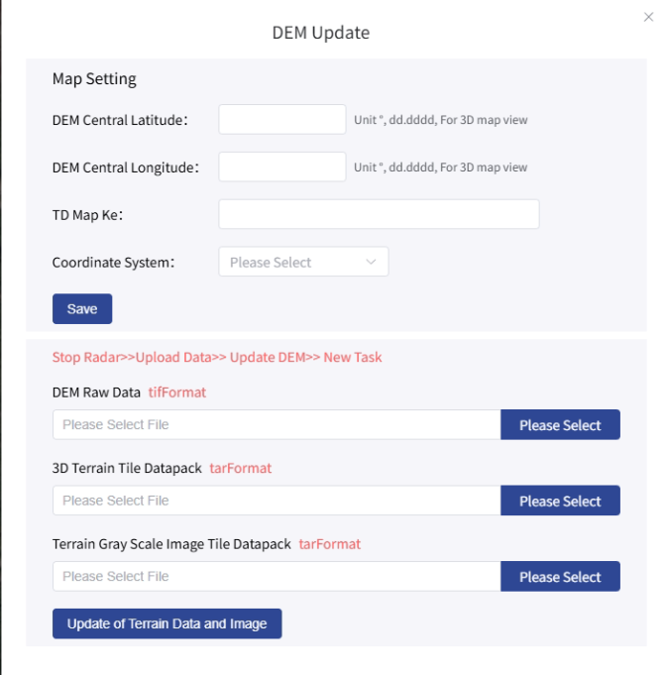
Figure 3-25 Update DEM

Communication Log
Viewing the radar communication log is supported on the dashboard.
Open the settings window through the toolbar: <Settings> — <Communication Log>
On the left side of the communication log window, you can view the history of command sending records. You need to select the radar to view, and filtering by time range and command type is supported, along with exporting log files in Excel format. The blue text content in the list is a link; click to view the detailed content of the command. (As shown in Figure 3-26)
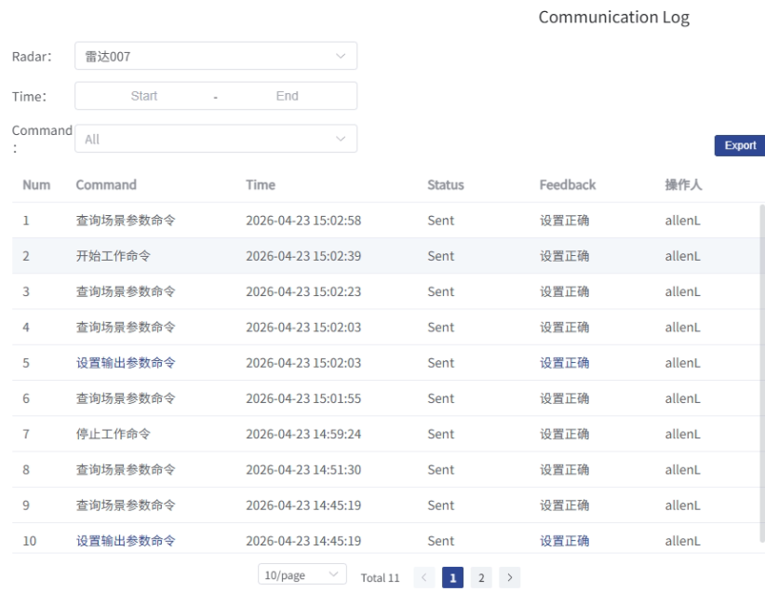
Figure 3-26 Communication Log – History Commands
On the right side of the communication log window, you can view the real-time communication log of the radar. The list will automatically update with records each time data is sent or received. (As shown in Figure 3-27)
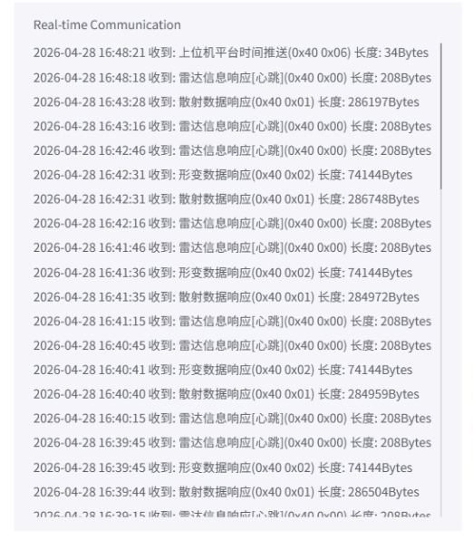
Figure 3-27 Communication Log – Real-Time Communication

Project Management

Create Project
In the "All Projects" section of the "Project Management" module, creating a new project is supported. Click "Create Project," enter information such as project name, project type, project address, and affiliated unit according to the pop-up prompts, and click "Create" once finished (as shown in Figure 3-28) to complete the project creation operation.
<Project Management> — <All Projects> — <New> — [Enter information as prompted] — <Create> — Creation complete
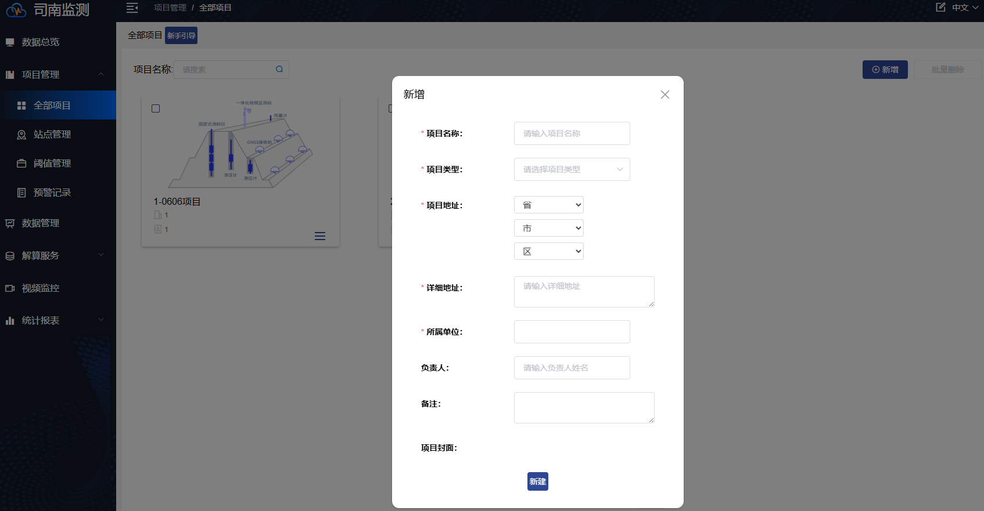
Figure 3-28 Create Project

Project Profile
In the "All Projects" section of the "Project Management" module, click the "..." in the lower-right corner of the corresponding project card, then click "Details" to view the specific information of the selected project (as shown in Figure 3-29), including project name, project type, affiliated unit, project address, person in charge, number of alarms, creator, creation time, etc. (as shown in Figure 3-30). Click the button in the upper-right corner of the page to switch the project view to list view (as shown in Figure 3-31).
<Project Management> — <All Projects> — <...> — <Details> — View details
<(Select Project)> — <(Select Target Project)> — Project switch complete
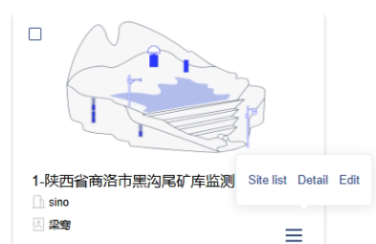
Figure 3-29 Project Options
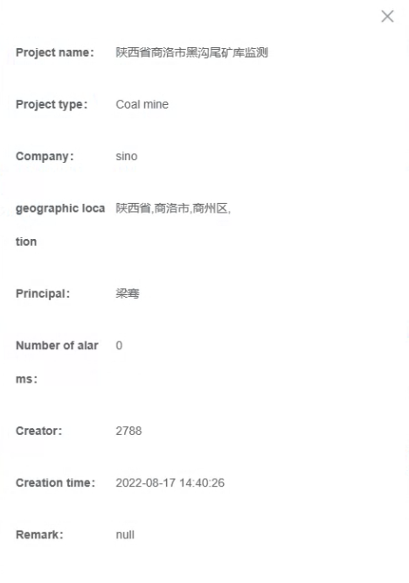
Figure 3-30 Project Profile

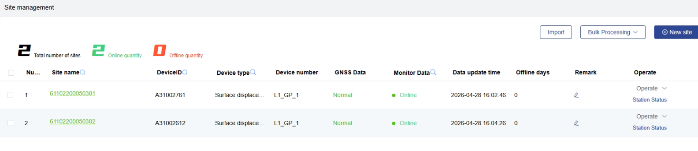
Figure 3-31 List View

Project Search
In the "All Projects" section of the "Project Management" module, project search is supported (as shown in Figure 3-32). Exact matching is supported: searching the full project name will directly display the target project. Fuzzy matching is also supported: searching part of the project name will display all projects containing the search term in their names, allowing you to select the desired project.
[Keyword] — <(Select Project)> — <Search> — Find project
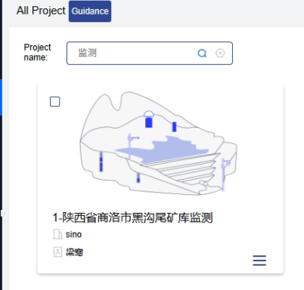
Figure 3-32 Project Search

Project Edit
In the "All Projects" section of the "Project Management" module, project information modification is supported. Click the "..." in the lower-right corner of the corresponding project card, then click "Edit" to edit the specific information of the selected project (as shown in Figure 3-33). Alternatively, in the "Project Information" section of the "Project Management" module, switch projects via the upper-left corner to view and edit the specific information of the corresponding project, and click "Save" in the upper-right corner after editing (as shown in Figure 3-34).
<Project Management> — <All Projects> — <...> — <Edit> — Edit complete
<Project Management> — <Project Information> — [Edit as needed] — <Save> — Edit complete
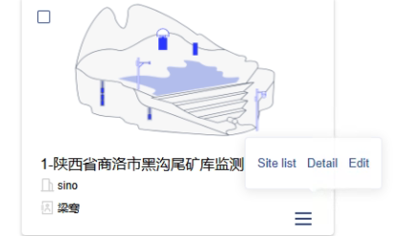
Figure 3-33 Project Edit

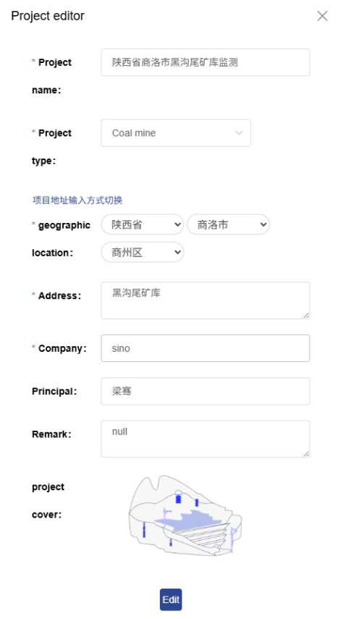
Figure 3-34 Project Information Edit

Delete Project
In the "All Projects" section of the "Project Management" module, project deletion can be performed. Select the check box in the upper-right corner of the corresponding project card, then click "Delete" in the upper-right corner of the page to complete the project deletion operation (as shown in Figure 3-35).
<Project Management> — <All Projects> — <(Select Project)> — <Delete> — Delete complete
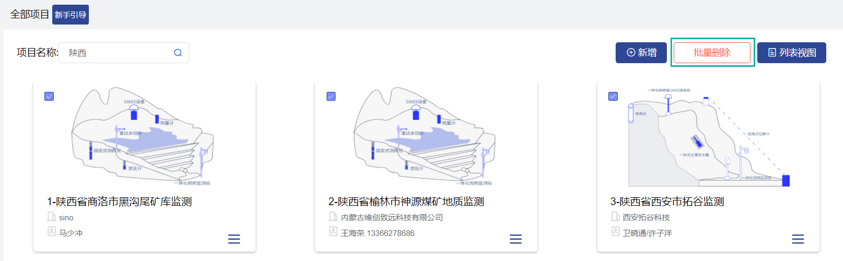
Figure 3-35 Project Deletion

Map Jump
In the "All Projects" section of the "Project Management" module, quick jump to the map view is supported. Select the project bar you want to view, click "Enter Project Site" (as shown in Figure 3-36) to jump to the actual location of the corresponding project in the "Map Monitoring" module.
<Project Management> — <All Projects> — <Enter Project Site> — Jump to Map Monitoring page
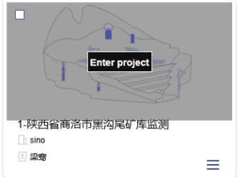
Figure 3-36 Map Jump

Site Management

Create Site
In the "Site Management" module, creating a new site is supported. Click "Create Site" (as shown in Figure 3-37), enter basic information (Site Name, Device SN, Device Type, Device ID, Transmission Method) and device location (Longitude, Latitude, Altitude) according to the pop-up prompts, then click "Create" (as shown in Figure 3-38) to complete the site creation operation. Map point selection is supported for location information; click "Map Point Selection" to open the map point selection window (as shown in Figure 3-39).
<Site Management> — <Create Site> — [Enter information as prompted] — <Create> — Creation complete
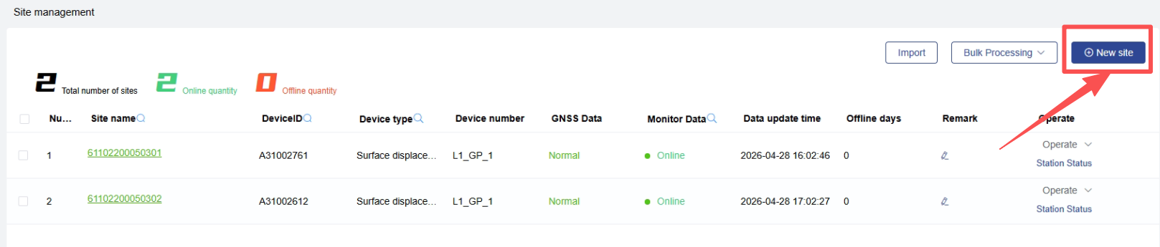
Figure 3-37 Site Management
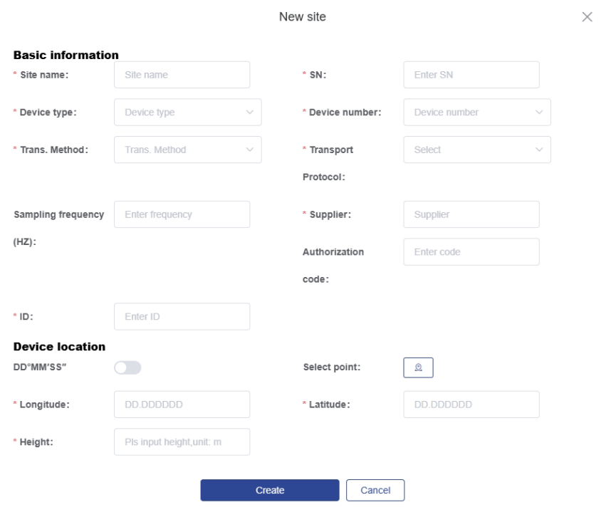
Figure 3-38 Create Site
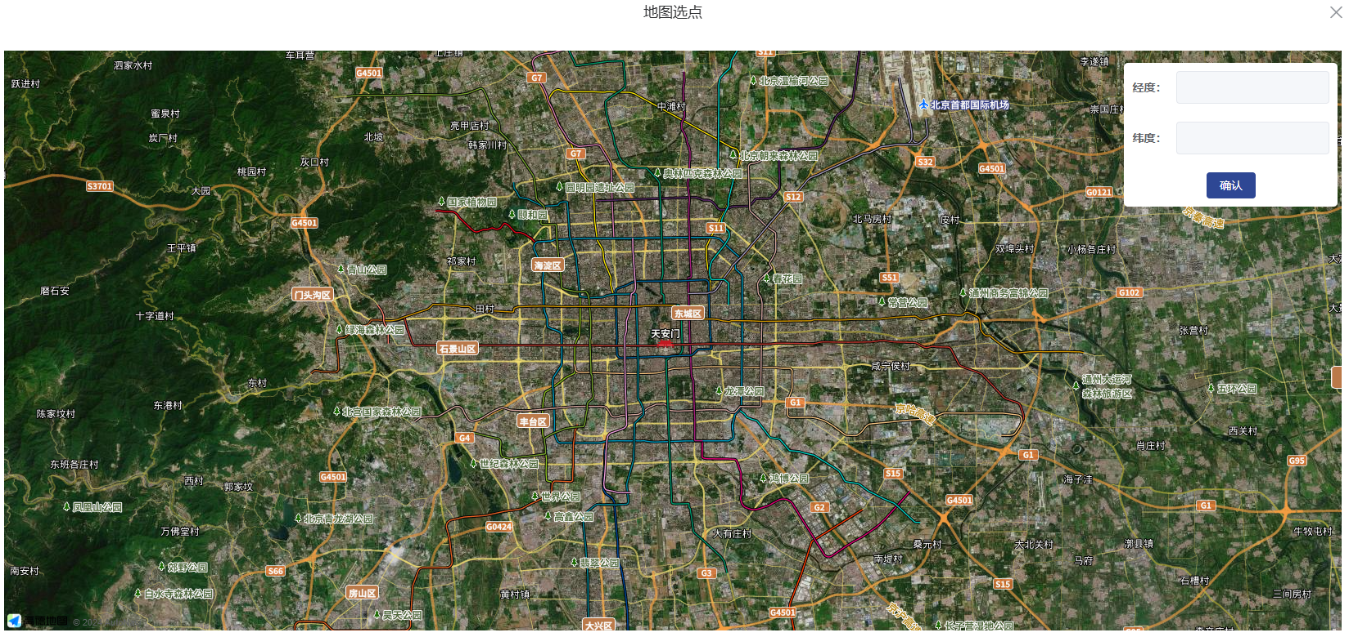
Figure 3-39 Map Point Selection

Site Edit
In the "Site Management" module, site information modification is supported. Click "Edit" on the right side of the corresponding site information bar to edit the specific information of the selected site, such as: Site Name, Device SN, Device Type and Number, Transmission Method, Device ID, Longitude, Latitude, Altitude, etc. (as shown in Figure 3-41).
<Site Management> — [Edit as needed] — <OK> — Edit complete
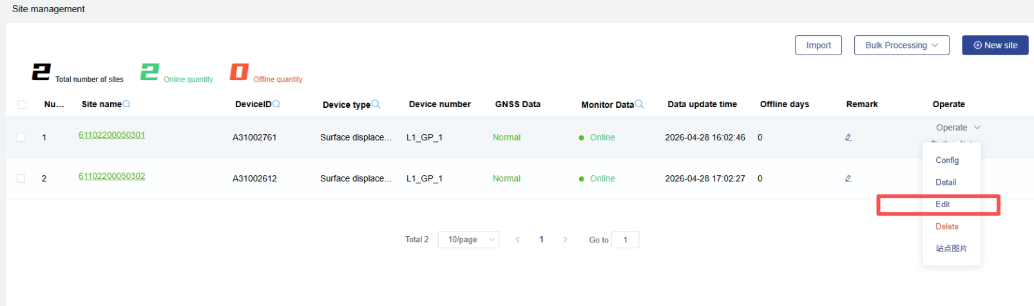
Figure 3-40 Site Edit
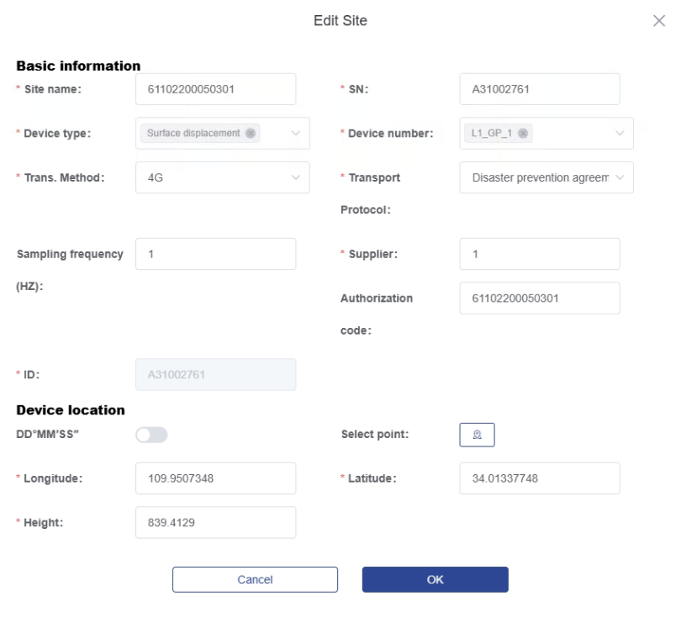
Figure 3-41 Site Edit Page

Information Display
In the "Site Management" module, site information viewing is supported. Click "Details" on the right side of the corresponding site information bar to view the specific information of the selected site; this operation is view-only and cannot be modified (as shown in Figure 3-42). Click the site name (colored text part) to jump to the data management interface for that site.
<Site Management> — <Details> — View complete
<Site Management> — <(Site Name)> — Jump to Data Management page
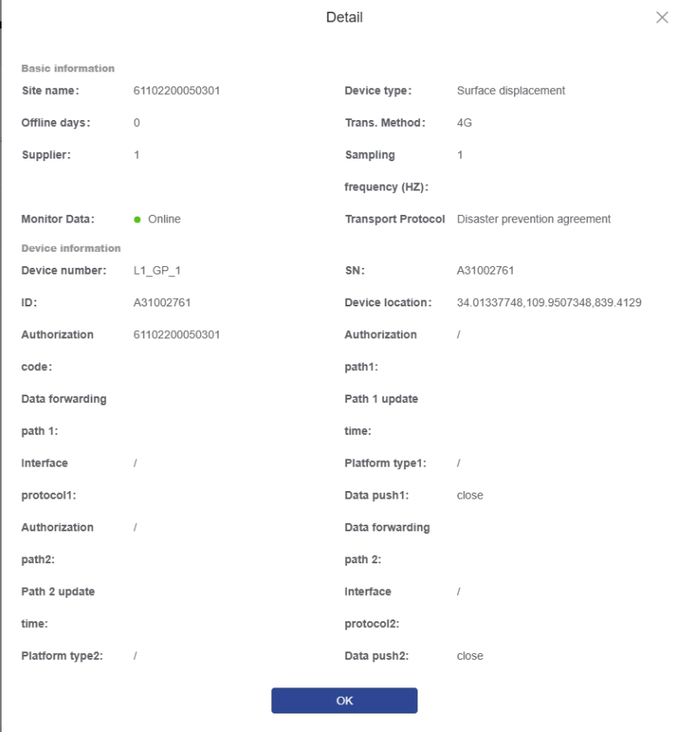
Figure 3-42 Site Information Display

Site Search
In the "Site Management" module, project search and condition filtering are supported. Switch projects via the upper-left corner to view the specific information of the corresponding project and select the desired project (as shown in Figure 3-43). Condition filtering is supported; by entering keywords and selecting device types, search for site information in the project that meets the conditions (as shown in Figure 3-44).
<(Select Project)> — <(Select Target Project)> — Project switch complete
[Keyword] — <(Select Condition)> — <Filter> — Find site
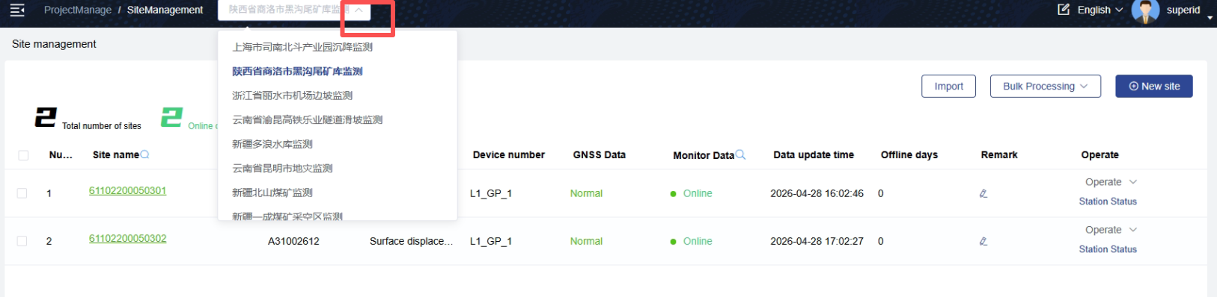
Figure 3-43 Project Selection

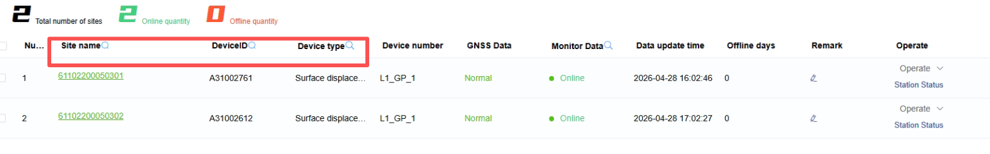
Figure 3-44 Search Bar

Multi-Sensor Management
In the "Site Management" module, managing multiple sensor types and setting device numbers based on sensor type is supported (as shown in Figure 3-45).
<Create Site/Edit> — <(Select Device Type)> — Multi-select complete
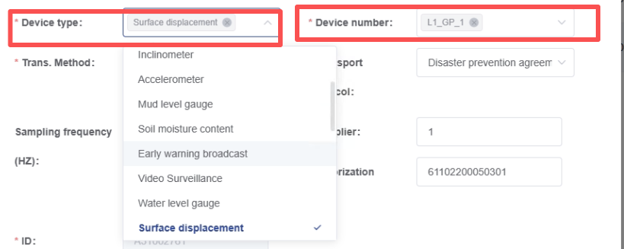
Figure 3-45 Device Numbering

Batch Import
In the site management module, select the batch import button, then select the corresponding site table file to import.
<Site Management> — <Import> — Select file and complete import
Instructions for filling in the import table are as follows:
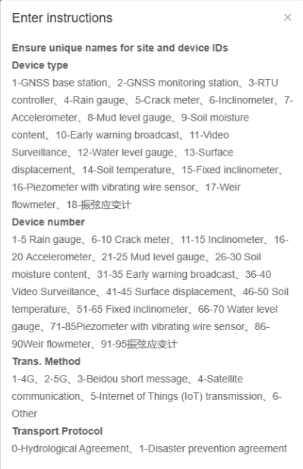
Device Type and Device Number are of int type. The corresponding numerical relationships are:
Device Type: 1-GNSS Base Station, 2-GNSS Monitoring Station, 3-RTU Controller, 4-Rain Gauge, 5-Crack Meter, 6-Inclinometer, 7-Accelerometer, 8-Mud Water Level Meter, 9-Soil Moisture Meter, 10-Early Warning Broadcast, 11-Video Surveillance, 12-Water Level Meter, 13-Surface Displacement, 14-Soil Temperature, 15-Fixed Inclinometer, 16-Vibrating Wire Piezometer, 17-Weir Meter, 18-Vibrating Wire Strain Gauge
Device Number: 1-5 for Rain Gauge, 6-10 for Crack Meter, 11-15 for Inclinometer, 16-20 for Accelerometer, 21-25 for Mud Water Level Meter, 26-30 for Soil Moisture Meter, 31-35 for Early Warning Broadcast, 36-40 for Video Surveillance, 41-45 for Surface Displacement, 46-50 for Soil Temperature, 51-65 for Fixed Inclinometer, 66-70 for Water Level Meter, 71-85 for Vibrating Wire Piezometer, 86-90 for Weir Meter, 91-95 for Vibrating Wire Strain Gauge.

Early Warning Setting
In the "Site Management" module, batch binding of thresholds already set under the project is supported. (As shown in Figure 3-46).
<Site Management> — <(Select Sites)> — <(Bulk Process)> — <(Forwarding configuration)> Complete early warning setting
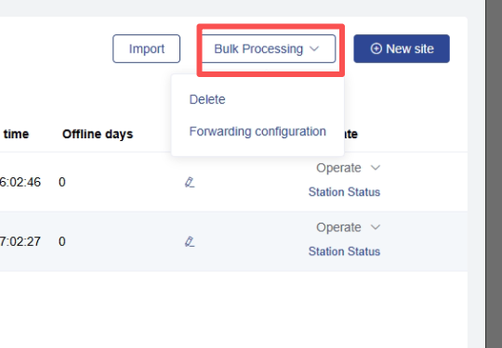
Figure 3-46 Early Warning Setting

Data Forwarding
In the site management module, the function to forward calculation results to other external platforms is supported. Click Configure, select the interface protocol, platform type, authorization path, and data forwarding path as required, and enable data push. (As shown in Figure 3-47)
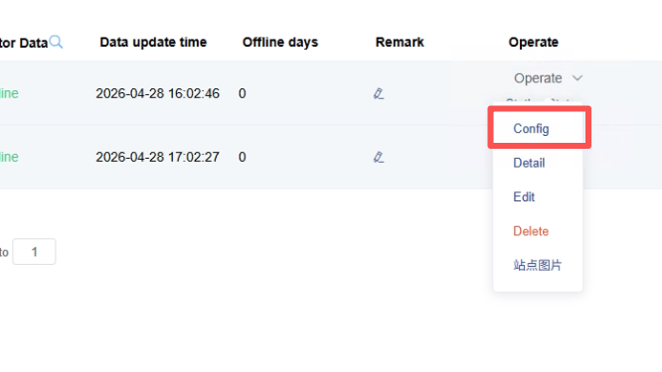
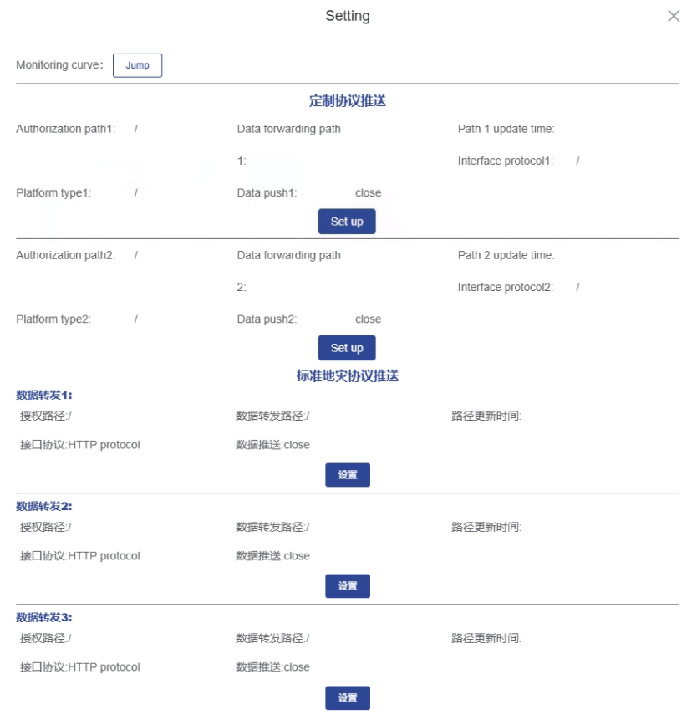
Figure 3-47 Data Forwarding

Early Warning Management

Threshold Management
In the "Threshold Management" section of the "Early Warning Management" module, creating and editing thresholds are supported. Click "Create Threshold" in the upper-right corner of "Threshold Management" (as shown in Figure 3-48), enter the threshold name and select the threshold type, then fill in the four-level alarm threshold values (Blue, Yellow, Orange, Red) as prompted to complete creation (as shown in Figure 3-49). Modifying or deleting existing thresholds is supported; click "Edit" or "Delete" on the right side of an existing threshold to modify or delete it (as shown in Figure 3-50).
<Early Warning Management> — <Threshold Management> — <Create Threshold> — [Enter information as prompted] — <Create> — Creation complete
<Early Warning Management> — <Threshold Management> — <(Select Threshold)> — <Edit/Delete> — Edit/Delete complete
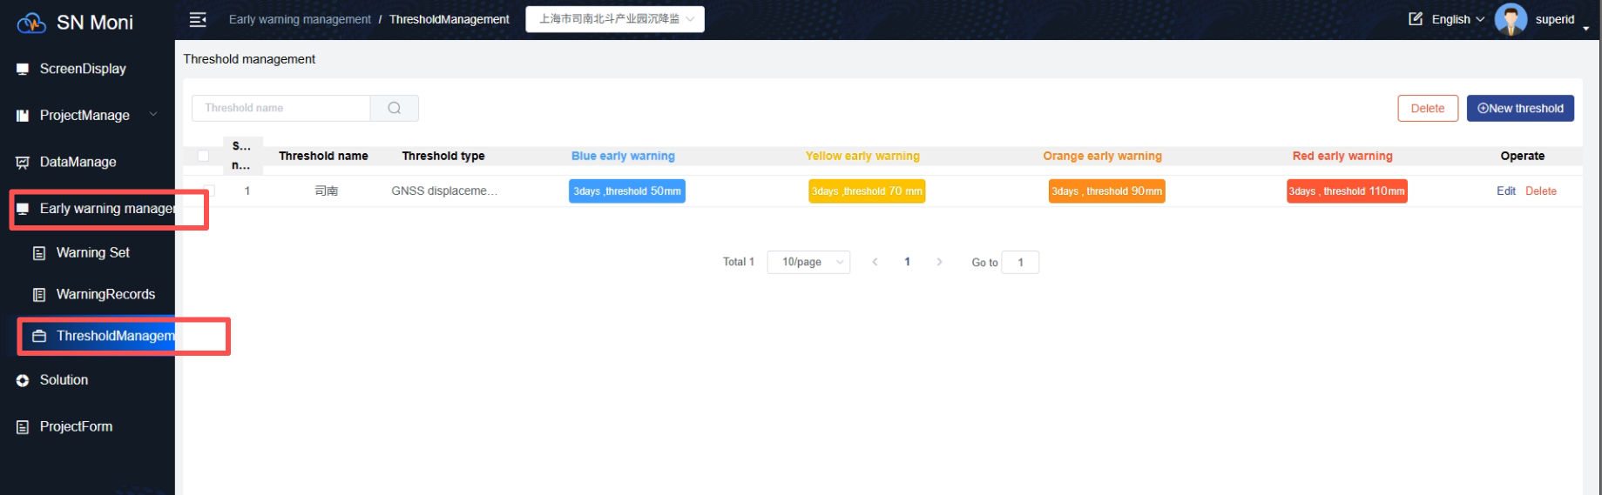
Figure 3-48 Threshold Management
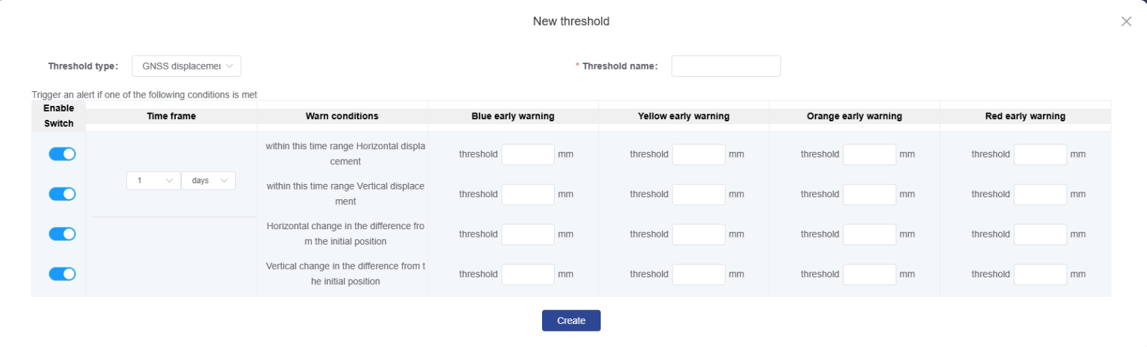
Figure 3-49 Create Threshold
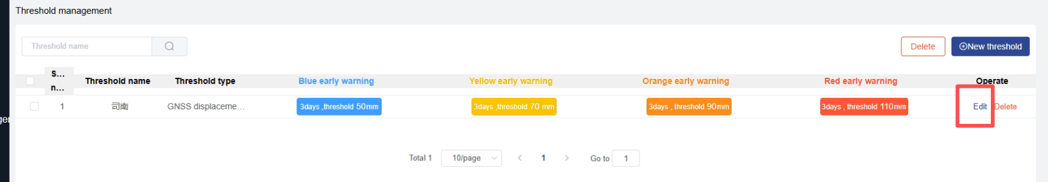
Figure 3-50 Threshold Edit

Early Warning Processing
In the "Early Warning Records" section of the "Early Warning Management" module, you can view and process early warning information generated by exceeding thresholds, as well as the processing status. Click "View" on the right side of an early warning record in "Early Warning Records" to view information such as the monitoring point name, device type, early warning level, early warning message, status, contact phone number of responsible person, and early warning time. If the early warning has already been processed, you can also view corresponding information such as processing time, processor, alarm reason, processing method and results (as shown in Figure 3-51). Click "Process Warning" on the right side of an early warning record in "Early Warning Records" to process the selected early warning information; fill in the processor, alarm information, processing method (Remote Debugging, On-site Debugging, Equipment Replacement), processing result, and alarm processing remarks as prompted (as shown in Figure 3-52).
<Early Warning Management> — <Warning Records> — <(Select Record)> — <View> — View complete
<Early Warning Management> — <Warning Records> — <(Select Record)> — <Process Warning> — [Enter information as prompted] — Processing complete
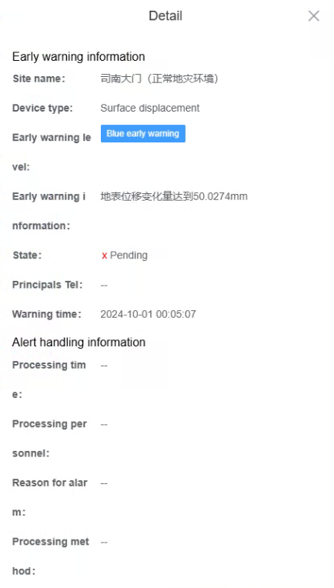
Figure 3-51 Early Warning Processing Page

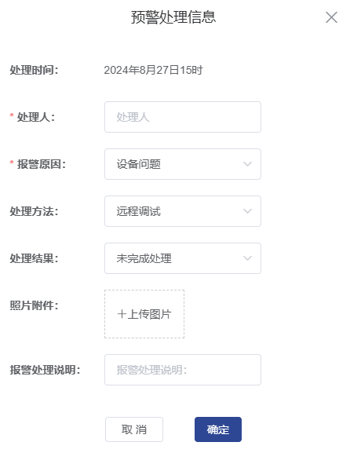
Figure 3-52 Process Warning

Alarm Information Export
In the "Early Warning Records" section of the "Early Warning Management" module, exporting early warning records is supported. Click "Export" in the upper-right corner of "Early Warning Records" (as shown in Figure 3-53), and the browser will automatically download the file to the default folder; open the exported file (as shown in Figure 3-54).
<Early Warning Management> — <Early Warning Records> — <Export> — Export record complete
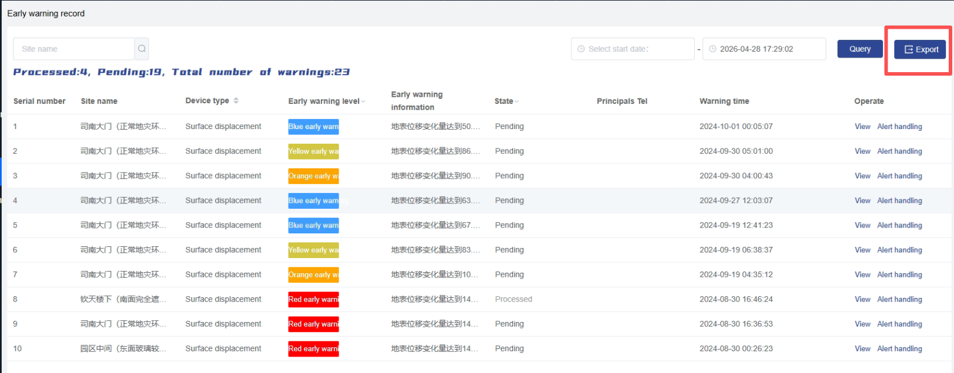
Figure 3-53 Warning Export
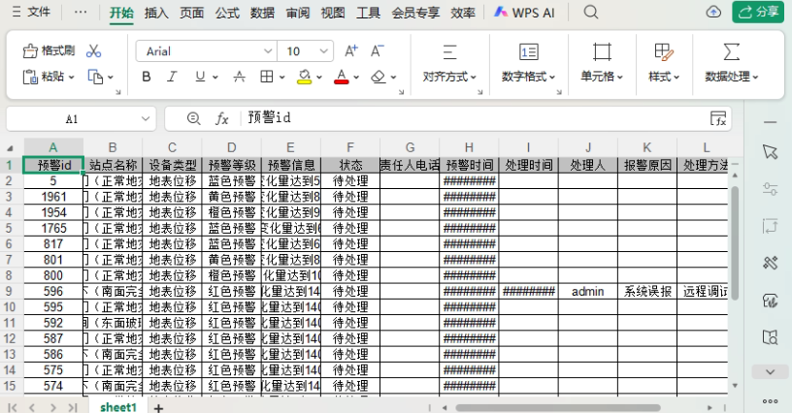
Figure 3-54 Warning Export Table

Alarm Information Search
In the "Early Warning Records" section of the "Early Warning Management" module, alarm information search is supported. Click the project switch box in the upper-left corner to switch between different projects (as shown in Figure 3-55). Click the search box above the early warning information to enter search content (supports searching for specific sites or responsible persons) and select filter boxes (Early Warning Level, Status, Date) to complete information search and filtering (as shown in Figure 3-56).
<(Select Project)> — <(Select Target Project)> — Project switch complete
<Early Warning Management> — <Early Warning Records> — <(Select Conditions)> — <Query> — Find record
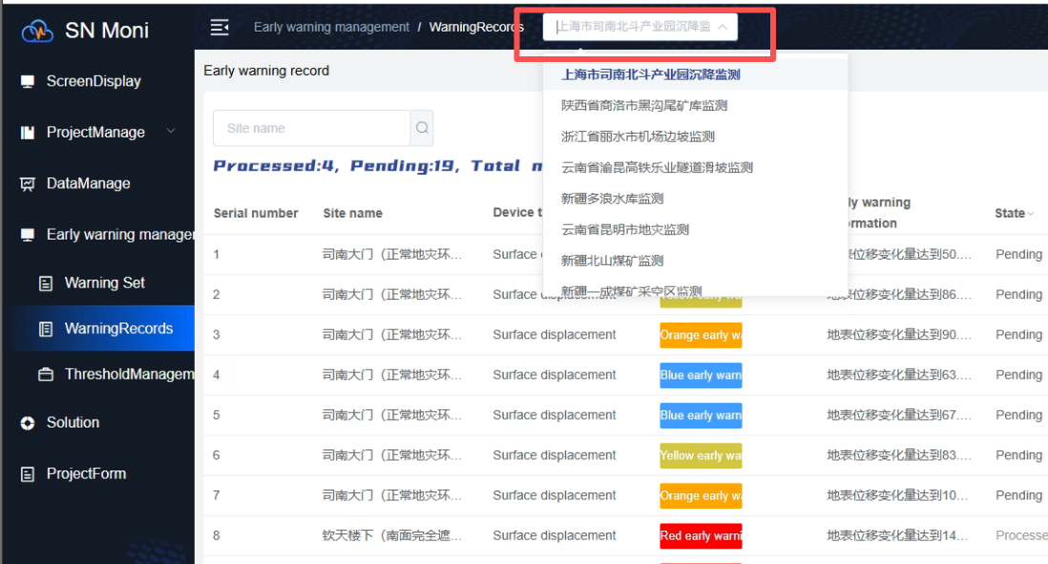
Figure 3-55 Project Switching
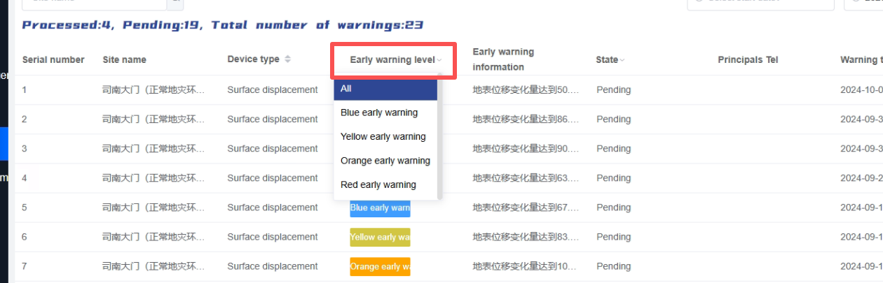
Figure 3-56 Warning Filtering

Data Management

Data Display
In the "Data Management" module, viewing the data change graph for each site sensor is supported. Setting a date range to display data changes is supported, and displaying data change graphs for different parameters simultaneously or individually is supported. Click "Today," "This Month," or "This Year" in the upper-right corner of the data change graph to quickly switch data display among these three time periods. Click the date selection box to the right of "This Year" to select a specific date and view the data change graph for that specified date (as shown in Figure 3-57). Click to check/uncheck the colored parameter labels above the data change graph to display data change graphs for different parameters. Additionally, clicking "Single Screen" or "Multi-Screen" in the upper-right corner enables displaying data for a single device or multiple devices (as shown in Figure 3-58).
<Data Management> — <Today/This Month/This Year> — Display data for different dates
<Data Management> — <(Colored Parameter Labels)> — Display data for different parameters
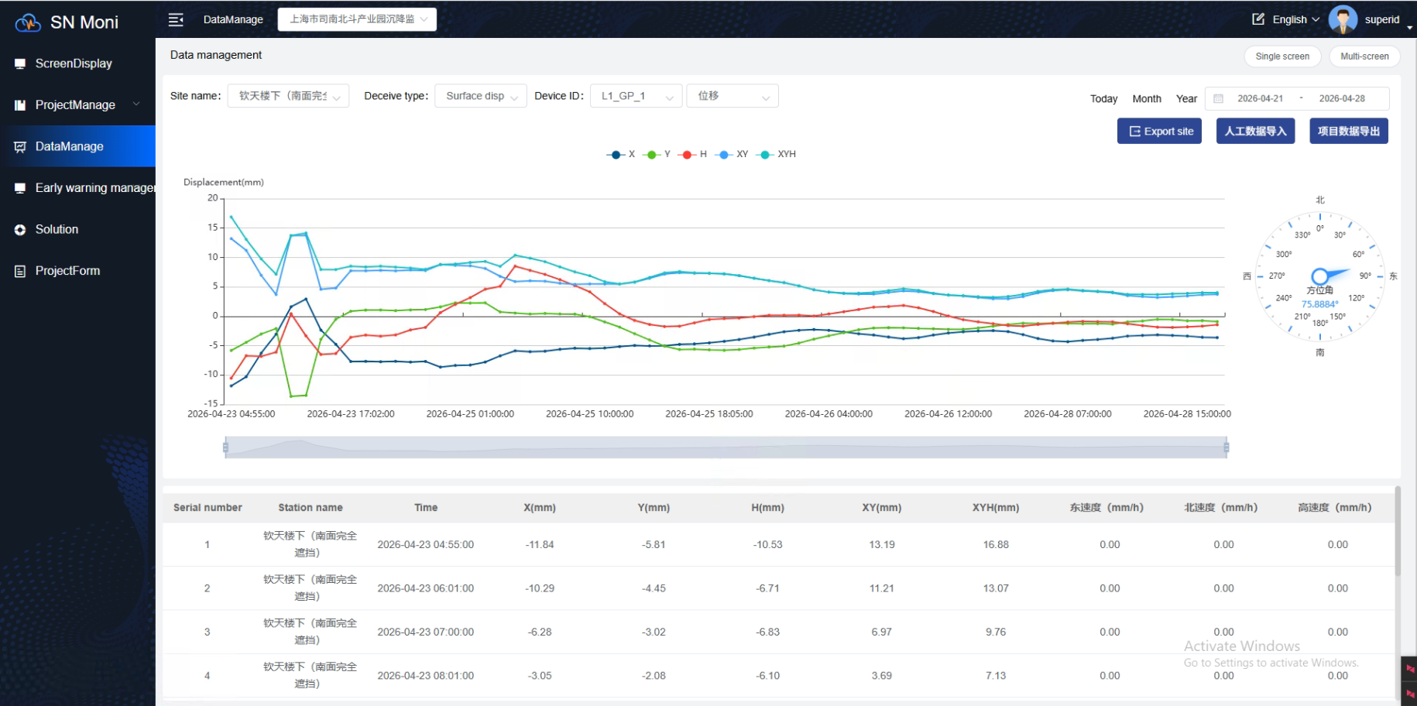
Figure 3-57 Data Filtering
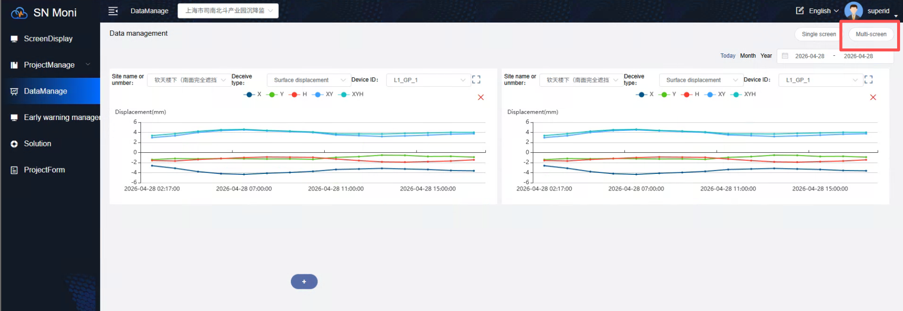
Figure 3-58 Data Type Filtering
Radar Device Data Display
For radar device data display, you need to first select the data history period, then select a time range. The time range must be within the history period. Multiple monitoring points can be selected to display multiple monitoring point data curves simultaneously. (As shown in Figure 3-59)
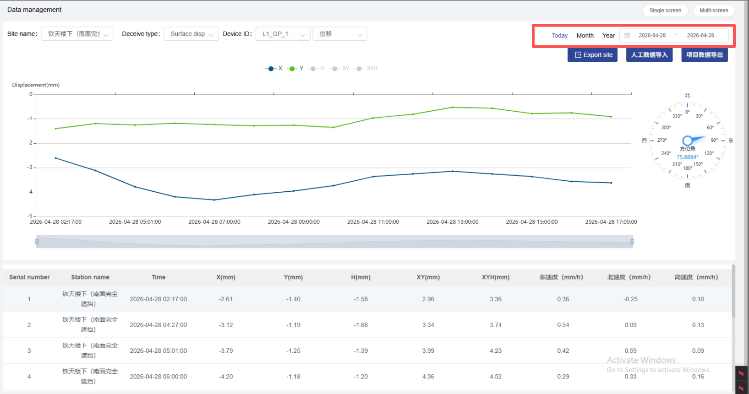
Figure 3-59 Data Type Filtering

Data Report
In the "Data Management" module, viewing or exporting data reports is supported (as shown in Figure 3-60). Click the export button below the data change graph to complete "Site Export."
<Data Management> — <Site Export> — Export record complete
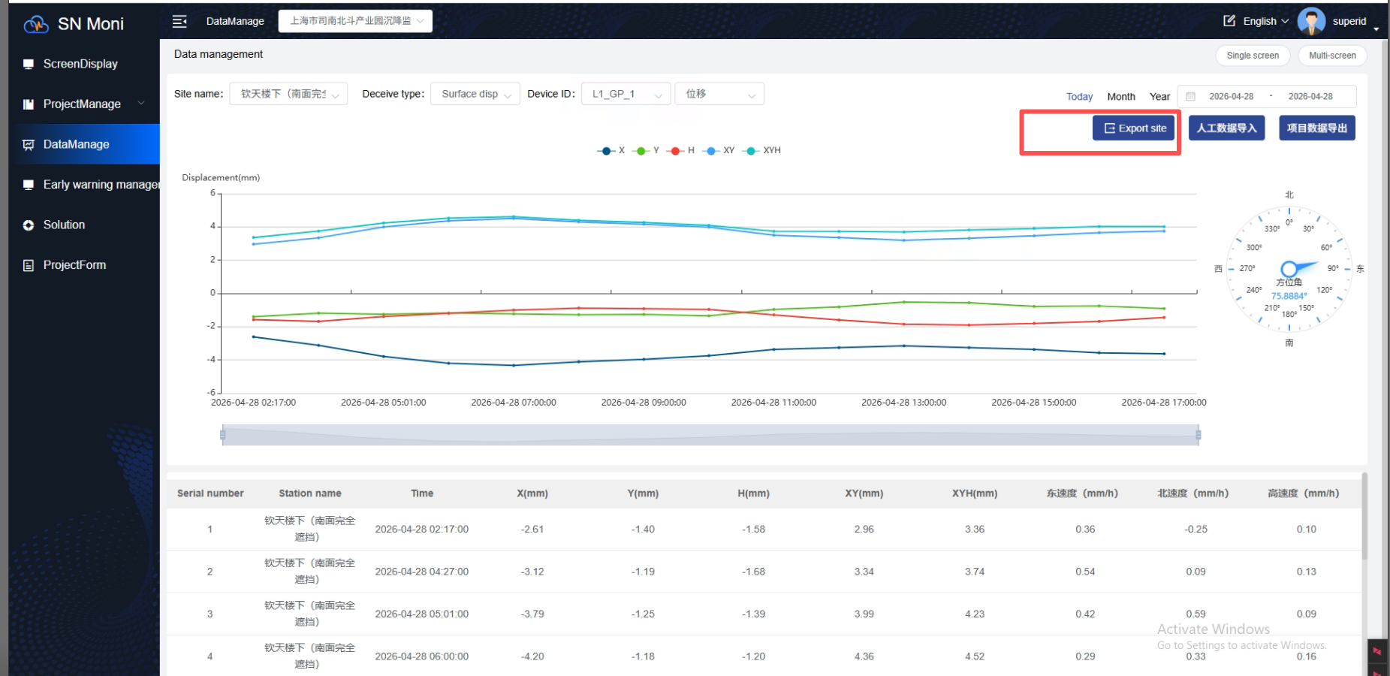
Figure 3-60 Data Report

Multi-Data Switching
In the "Data Management" module, switching site sensors to toggle the data change graph of the corresponding sensor is supported. Switching device numbers to toggle data change graphs of different devices of the same sensor type is supported. Click the selection boxes above the data change graph, select device type, device number, etc., to complete rapid switching of different data change graphs.
<Data Management> — [Keyword] — <(Select Condition)> — Switching complete
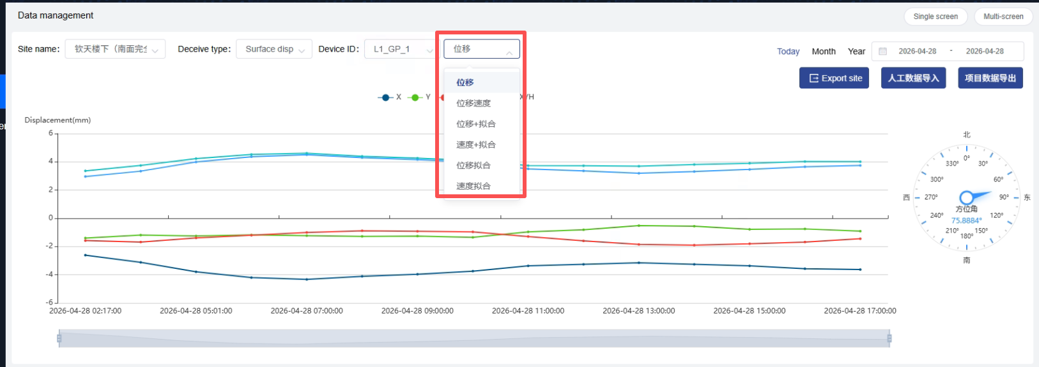
Figure 3-61 Device Type Switching

Site Switching
In the "Data Management" module, switch projects via the upper-left corner to view the site data for the corresponding project and select the desired project. Click "Site Name" to select a specific site and view the data change graph for the specified site (as shown in Figure 3-62).
<Data Management> — <(Select Name/Number)> — Switching complete
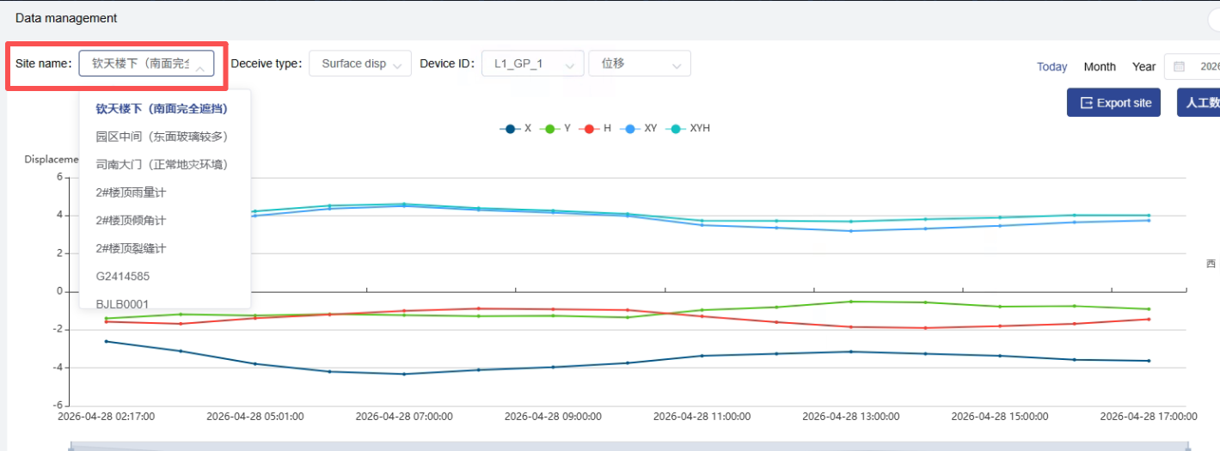
Figure 3-62 Site Switching

Statistical Reports

Project Report
In the project report, select a project to query. After querying, the number of early warnings under the current project is displayed. Mouse over to show the count of each early warning level. Click the icon to hide the line chart. The online count in the device ratio pie chart represents the number of currently online sites under the project; the online rate is calculated as online count / total sites. Query by This Week or This Month, and click "Export Report" to download site information. (As shown in Figure 3-63)
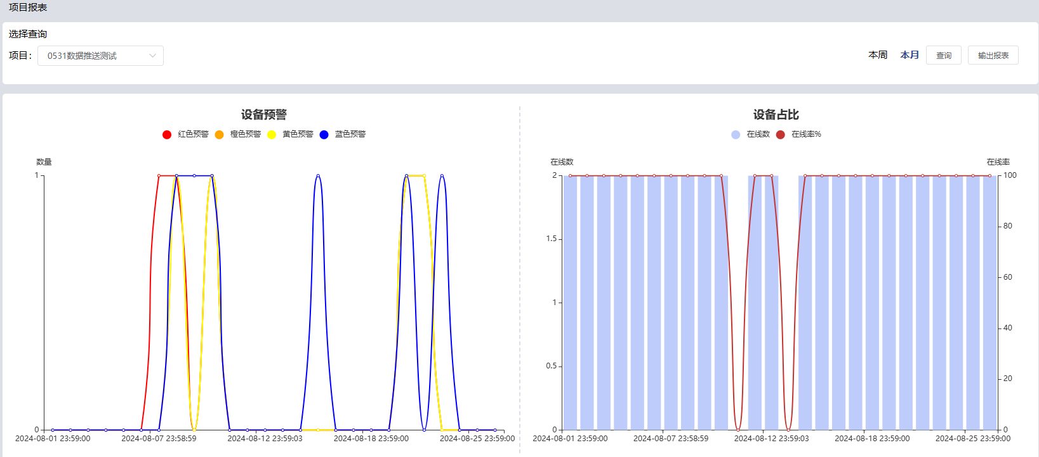
Figure 3-63 Device Early Warning

User Report
Upon first login to the platform, you need to register an account. Click the "Register Now" button on the login page to register. (As shown in Figure 3-64) Enter your mobile phone number, fill in the verification code, enter a password, confirm the password, agree to the terms, and click "Register Now." (As shown in Figure 3-65)
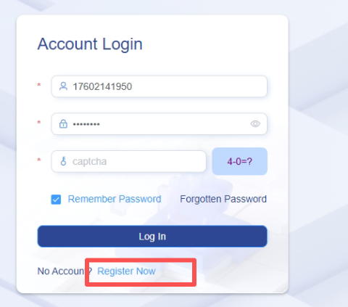
Figure 3-64 Register Now Button
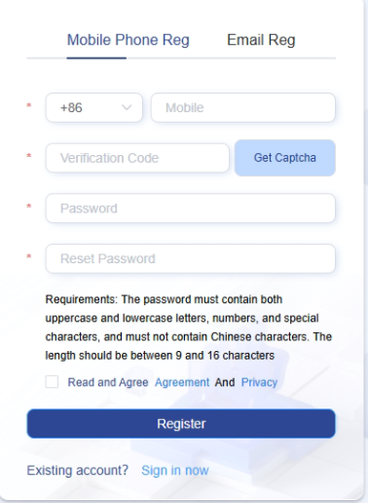
Figure 3-65 Register Now Page

Feedback
Click the icon in the upper-right corner to enter the feedback page. (As shown in Figure 3-66) Enter the issue or suggestion content, upload images (image format limited to jpg, png, jpeg; maximum six images can be uploaded), fill in the correct contact information, and then submit or reset. (As shown in Figure 3-67)
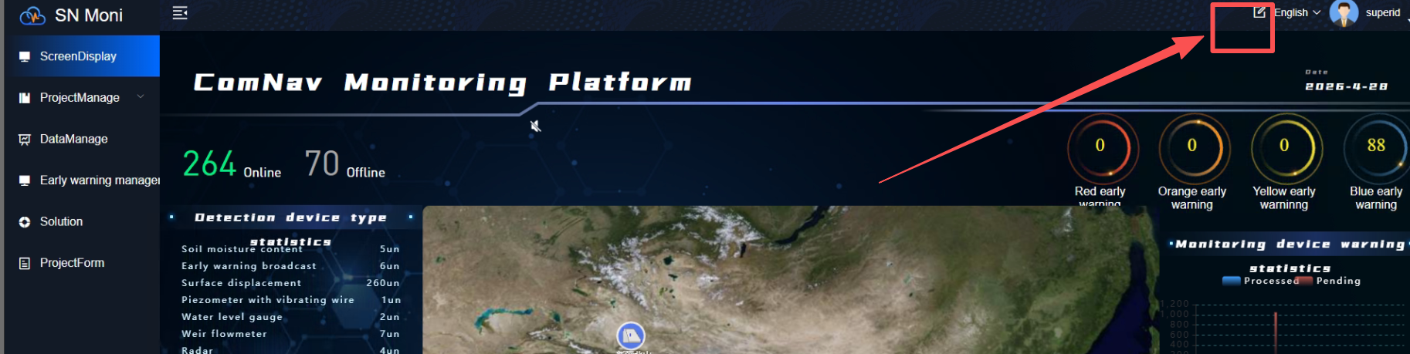
Figure 3-66 Feedback Button
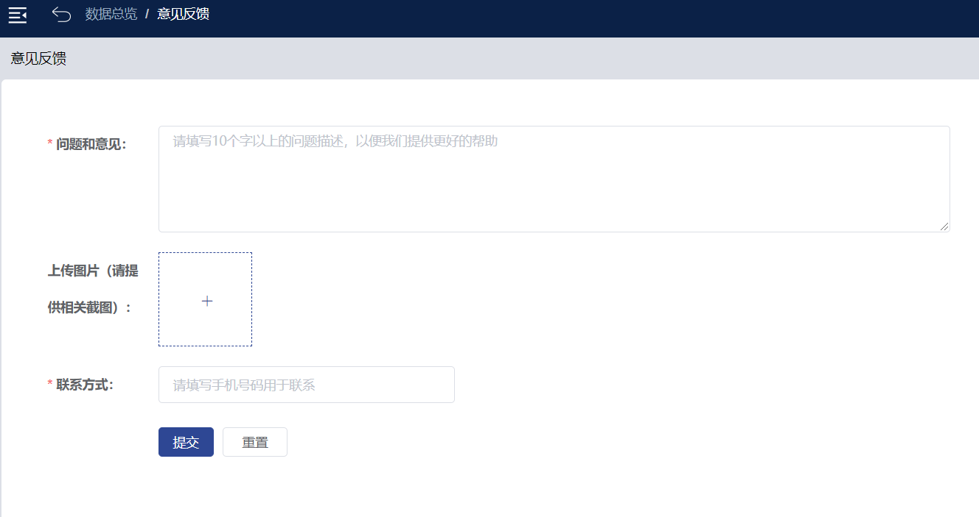
Figure 3-67 Feedback Information Display

